**Customer NAME**

**Project Server 2010**

**Basic Configuration**

*“Helping you build a Project Management Culture”*



Table of Contents

Project Server 2010 Basic Configuration 3

Chapter 1: Security Cleanup 4

Chapter 2: Enterprise Global Reset 4

Chapter 3: Project Details Quick Launch and PDP Views 5

Chapter 4: Duplicate Web parts, Quick Launch and Reminder Web Part Customization in Production 6

Chapter 5: Updated System Settings 6

Chapter 6: SQL Reporting Services 7

Chapter 7: Central Admin Configuration 7

Server Patch Level 7

Security 7

Outgoing Email Configuration 7

Services 8

Service Applications 10

Excel Services 10

PerformancePoint Services 11

Secure Store Service 11

Visio Graphics Service 11

Chapter 8: Disaster Recovery 11

# Server 2010 Basic Configuration

This document will cover the changes made to the PWA instance during the migration to the 2010 development server. The following areas will be covered:

1. Security Cleanup
2. Enterprise Global Reset
3. Project Center Quick Launch and PDP Views
4. Duplicate Web parts, Quick Launch and Reminder Web Part Customization
5. Updated System Settings
6. SQL Reporting Services
7. Central Administration Configuration
8. Disaster Recovery

# Chapter 1: Security Cleanup

All of the security was heavily customized in 2007. The security groups weren’t able to save. I found that there were some added security customizations to the published database from 2007, which caused the save to fail. I ran the following script on ProjectServer_Dev_Published:

select wsec_fea_Act_name_ID, conv_value, conv_String from dbo.MSP_WEB_SECURITY_FEATURES_ACTIONS

left join dbo.MSP_WEB_CONVERSIONS on WSEC_FEA_ACT_NAME_ID = CONV_VALUE

This returns all the security settings available. It showed three custom values from the dbo.msp_web_Security_features_actions table that were missing data in the dbo.msp_web_conversions table. I deleted these three entries from the dbo.msp_web_Security_features_actions table after taking a backup. I reset IIS on the app and web servers, and I removed dynamic compression in IIS on the web server, BRIUWVPRJWEB02. I also reset the project server events and queue services on the app and web servers.

At this point I could open a group, and if I reset the category and global settings, it would allow me to save the group. Once this was possible, the groups, categories, and templates were all reset to the out of the box default for Project Server 2010.

# Chapter 2: Enterprise Global Reset

In order to fix corruption in the Enterprise global template, I ran a script provided my Microsoft to run on the published database that will reset the enterprise global temple.

This script can found in the folder, C:\Program Files\Microsoft Office Servers\14.0\Sql\Project Server\CORE\1033 on the app server BRIUWVPRJAPP02. It was run on the published database, ProjectServer_Dev_Published. After completion, I opened all the resources in Project Pro and saved them, re-associating them with the standard calendar.

# Chapter 3: Project Details Quick Launch and PDP Views

After the 2007 system was migrated to the 2010 development environment, the quick launch of the project details page of a project didn’t display. Also, when viewing or editing a PDP, it would give an error and wouldn’t display properly. This was because of a migrated property that is set in the database for the PWA site collection that is only supposed to be set for a project server workspace.

The problem is explained in full detail here: <http://blogs.msdn.com/b/brismith/archive/2010/06/22/project-server-2010-cannot-create-or-edit-projects-in-project-center.aspx>

The fix is fully documented here: <http://blogs.msdn.com/b/brismith/archive/2010/05/07/project-server-2010-my-first-fix-with-powershell-a-pwa-site-that-thought-it-was-also-a-workspace.aspx>

The PowerShell commands that were run to fix the issue:

$Web = get-SPWeb http://bripwvprjweb02/bcbsri

$Web.AllProperties | Format-Table

The output of the second command showed me that PWAURL was set to the URL of the IT 2007 Production PWA site – so I could change this back to NULL again using PowerShell

$Web.AllProperties[“PWAURL”]=””

$Web.Update()

After this the project details quick launch and PDP pages displayed correctly.

# Chapter 4: Duplicate Web parts, Quick Launch and Reminder Web Part Customization in Production

After migration, all the web parts in PWA were duplicated. I deleted the duplicate web parts, and verified the out of the box confutation. Along with that I reset the reminders web part to the default of showing all reminders. I also reset the quick launch to show all navigation items, which is the out of the box setting.

# Chapter 5: Updated System Settings

All Project Server system settings were checked and verified.

* Fiscal Periods and Timesheet Periods were defined through 2013. Fiscal periods start on the first of the year, and follow the calendar. Timesheet periods are seven days, Saturday to Friday.
* Queue settings were verified for optimal performance.
* The enterprise project template was loaded and a custom enterprise project type (EPT) was created. The EPT was setup with the following settings:
  + No Workflow was used, but was configured with the Schedule and Project Details PDPs.
  + Creates a project site using the custom BCBSRI Standard EPT project site template.
  + Uses the EPMO Project Workspace Template2 project template.
* The Project Proposal Workflow EPT was setup with the custom project proposal workflow. It also uses the custom project template and custom site template.
* To get workflows running, we had to run the following commands on the app servers of each farm:
  + $webapp = Get-SPWebApplication -identity http://<web app name>
  + $webapp.UpdateWorkflowConfigurationSetttings()

# Chapter 6: SQL Reporting Services

There were access issues with SSRS initially, where the report library and report management sites were inaccessible. We reviewed and confirmed the base setup, and eliminated the firewall or proxy as a possible problem. We made a change to the configuration file in development. This was the process:

1. Backup and open the RSReportServer.config file, it is stored at <InstallDrive>:\Program Files\Microsoft SQL Server\MSRS10.<InstanceName>\Reporting Services\ReportServer
2. The setting Secure Connection Level was updated to a value of 0: <Add Key="SecureConnectionLevel" Value="0"/>
3. We also checked <URLReservations>, seeing if there were 2 <Application> child nodes in it, one containing the <Name> node ReportServerWebService and the other is ReportManger.
4. We then checked that the text in the node <VirtualDirectory> of ReportManager is the same as the virtual directory of ReportServerWebService.

This allowed the sites to be visible internally. When we replicated this in production later, the sites were accessible to externally as well and everyone could access it.

# Chapter 7: Central Admin Configuration

## Server Patch Level

SharePoint and Project Server have been updated to SP1 and the April 2012 CU.

## Security

The service account is BCBSRI\projectserver2010. The farm administrators are all local server administrators on BRIPWVPRJWEB02 along with the service account.

## Outgoing Email Configuration

Mail Server: 162.168.100.160

Email Address: SharePoint.Support@bcbsri.org

## Services

Services that are started and running on BRIPWVPRJWEB02

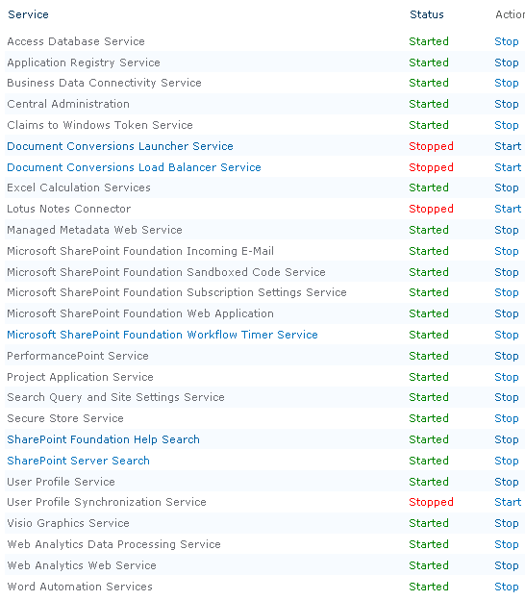

Services that are started and running on BRIPWVPRJAPP02

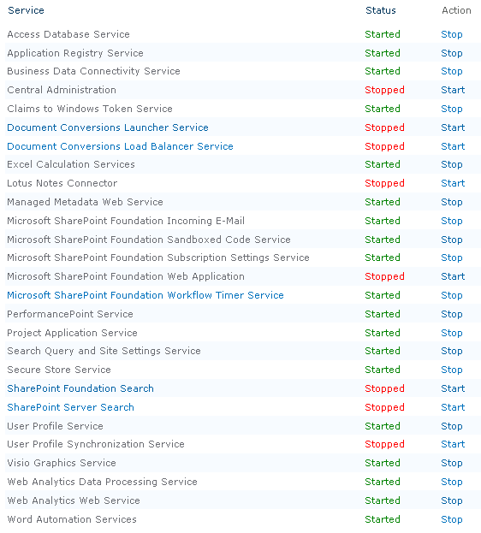

## Service Applications

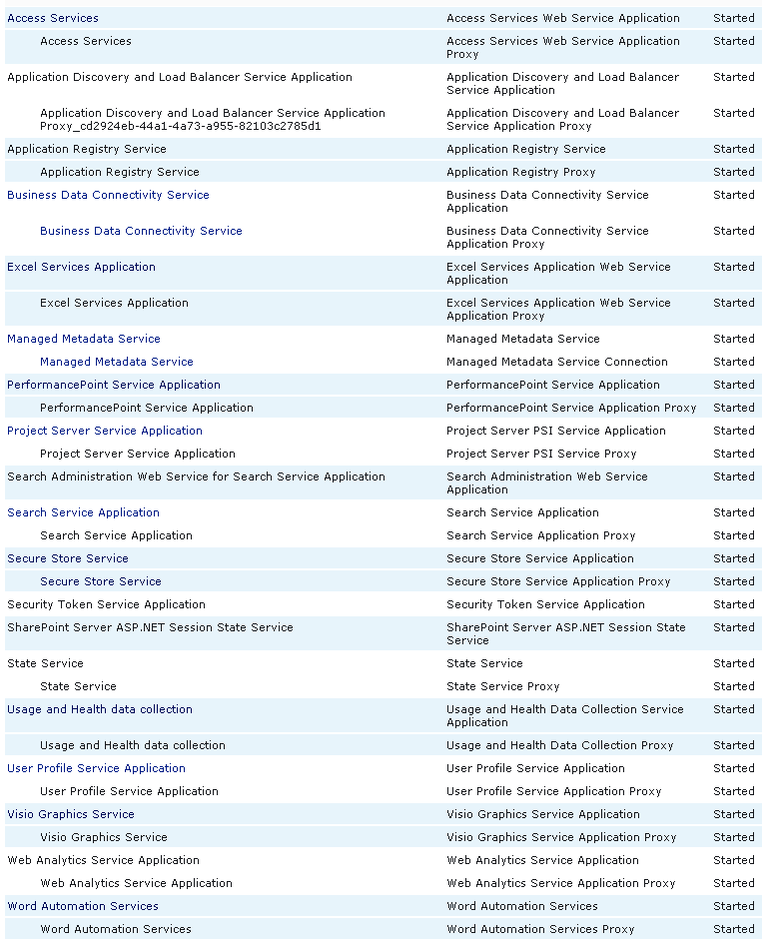

## Excel Services

General Settings:

* Allow Cross Domain Access: Checked
* Unattended Service Account: ProjectServerApplication

Trusted File Location Address: http://

* Workbook Calculation Mode: Automatic
* Warn on Refresh: Disabled
* Allow External Data Using REST: Enabled

Trusted Data Connection Libraries addresses setup:

* http://bripwvprjweb02/bcbsri/ProjectBICenter/Data Connections for PerformancePoint/English (United States)/
* http://bripwvprjweb02/bcbsri/ProjectBICenter/Data Connections for PerformancePoint/

## PerformancePoint Services

Unattended Service Account: BCBSRI\projectserver2010

## Secure Store Service

Setup target application: ProjectServerApplication

* Contact Email: EPMO@bcbsri.org
* Application Type: Group
* Admins: BCBSRI\projectserver2010 and Marie Berry
* Members: All Authenticated Users
* Security Credentials: BCBSRI\projectserver2010

## Visio Graphics Service

Unattended Service Account: ProjectServerApplication

# Chapter 8: Disaster Recovery

In case of a complete system failure, we can recover using the file system, SharePoint, and SQL backups. Each of these elements needs to be backed up for full recovery:

1. Do a standard file system backup of the 14 hive: C:\program files\common files\ Microsoft Shared \web server extensions\14. This is the folder that has any customization that was done.
2. Do a full SQL backup of all databases weekly with a daily differential.
3. Perform a full SharePoint farm backup in central administration:
   1. In Central Administration, select Backup and Restore
   2. Under Farm Backup and Restore, select Perform a backup
   3. Select the checkbox next to farm and click next.
   4. Select to do a full backup, with content and configuration.
   5. The backup location has to be to a shared location using the \\[servername]\[folder name] format.

The restore process follows these basic steps:

1. Recreate each server in your farm, web, application, and SQL, using the same server names and IP addresses. Use the same operating system and everything. The goal is to be a similar to the original hardware as possible.
2. Install SQL on the new SQL server, following best practices for performance.
3. Restore all the databases using the same names.
4. Install SharePoint and Project Server in the web and application servers. Apply the same service packs and cumulative updates to each server.
5. When running the configuration wizard, point to the restored configuration database. Be sure to have the farm passphrase handy, as it will ask you to enter that. Do this same process on each server in the farm (outside of SQL).
6. Restore the file system backups for the 14 hive on each SharePoint server. This restores any customization that was added.
7. Restore the SharePoint farm backups in Central Administration:
   1. In Central Administration, select Backup and Restore
   2. Under Farm Backup and Restore, select Restore from a backup
   3. Enter the same backup location from when you took the backup \\[servername]\[folder name].
   4. Select to restore everything but the content databases.
8. Once your SharePoint farm has been restored, verify that the services and service applications are all created and running, and that the web applications all exist.